**Invisible Aircraft**

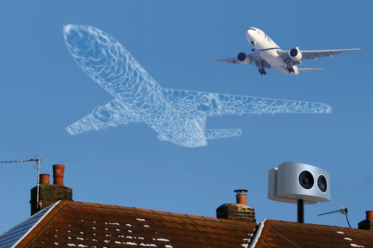

Airports are centers of economic activities. As a consequence airport attract business activities, both directly related to the air station function and businesses that are depending on air freight and easy access to air transport. Consequently, many people want to live near to their working place and thus near to the airport. Cities and airports expand and because of the increasing air traffic, there are complaints from the people living near the airport about aircraft noise, pollution and smell. Experience has shown that when traffic increases even at constant noise levels due to improvements in aircraft technologies, the complaints about nuisance from aircraft noise tend to rise. Noise is therefore not an absolute issue but a question of perception.

One solution to alleviate the problem is to make aircraft invisible and to make them silent. In the military domain work is carried out to create visual stealth. The active camouflage technologies range from using light to illuminate the aircraft, amongst others by using fluorescent panels. Research is also focused on electro optical camouflage using electro-chromic polymer materials. Aircraft could be covered with a coating of LCD’s.

Photosensitive receptors scan the surrounding of the Aeroplan and a picture is displayed on the LCD’s. This technology would make the aircraft virtually invisible as it blends with the surrounding.

Anti-noise would be used to counter the noise of the aircraft. Already tests are performed to see if anti-noise technology can be used to compensate for aircraft noise inside a house. The technology could be expanded to create anti-noise in areas located near to the departure and arrival tracks at airports.  
Aircraft themselves can be made silent by avoiding airframe noise produced by high lift devices, the undercarriage and aircraft cavities.